Czech University of Life Sciences

Faculty of Economics and Management

Department of Information Technologies

**Desktop and Mobile keyboards**

|  |  |
| --- | --- |
| INFOAP  2011-2022  17.03.2022 | Artem Makurin |

# Table of contents

Table of contents 1

How keyboard appeared in every household 2

The return of the Mechanical switch 4

The keyboard renaissance 10

List of figures 14

Bibliography 15

# How keyboard appeared in every household

Contemporary keyboards come in many shapes and forms. The original QWERTY layout is a rather old invention, dating all the way back to 1868 when an American inventor Christopher Latham Sholes patented the first modern typewriter.[1] The modern keyboard technology, though, is much younger than that.

The keyboard went through many shapes and forms before it ended up in almost every household around the world. A big reason for competitiveness in keyboard market has to be attributed to the increasing popularity of the home computer as a whole.

First computers that researchers of today can safely call **true** home PCs appeared in 1977 and back then they used keyboards that weren’t as great as the modern ones. The keys wore out quickly[2], were subject to keybounce[3], were cramped and terrible to use. Something had to be done.

In 1977, IBM received a patent[4] for a „Buckling Spring“ key mechanism which had a small spring attached to the underside of every keycap. IBM has used this patent and capacitive technology in order to develop one of the earliest **good** keyboards: the *IBM 4704 Model 200* (also known as Model F) in 1981, later followed by an even more popular *Model M* in 1986, which, surprisingly, still has a cult following today.[5]

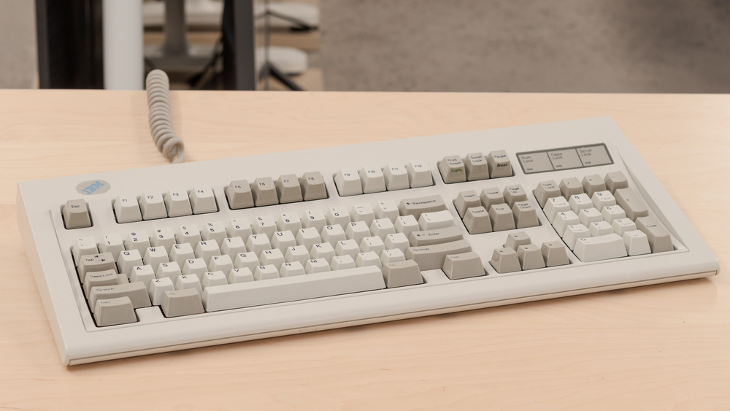

Figure 1 - *IBM Model M*. [6]

The Mechanical switch technology that is widely used today has its’ roots deep in history as well. In fact, keyboard that was used in the first computer at UCLA back in 1970s technically had mechanical reed switches. [7]

Interestingly, three out of four professional-grade keyboard technologies that are used today have been in development for a long time as well. These three are, namely, keyboards using Hall Effect, Capacitive keyboards and Optical keyboards, with Analog keyboards being a notable exception.

In its‘ core, Hall Effect is a tiny voltage present across (as opposed to along) an electrical conductor when a magnet is placed in proximity to it while it conducts current.[8] However, when applied to keyboards Hall Effect means that, unlike the conventional Mechanical switch where two metals needs to contact, there is no physical interaction of components happening, which leads to increased durability in the long run. One of the first keyboards that made this technology popular was the *Space-cadet keyboard* which was designed in 1978.[9]

Capacitive keyboards, on the other hand, were designed to make use of the keyboard’s changes in capacitance. The capacitor is placed under each key. They have heritage from as early as 1979 with IBM using the Capacitive technology in their early Buckling Spring keyboards.[10]

Optical keyboards, again, proposed a different approach. Also known as photo-optical keyboards, they use light to trigger a particular key.[11] When pressed, the light will be blocked, making the keyboard notice the blockage as a keystroke. Optical keyboard technology is an old invention as well, with the concept being proposed as early as 1962 by Harley E. Kelchner to reduce noise generated by a typewriter.[12] The earliest modern functioning developments can be traced back to the early 1980s.[13]

What truly brought a keyboard into every household, though, was the same thing that almost killed every other type of keyboard technology. It was the Membrane keyboard and its‘ iterations, such as the Rubber Dome Switch, Scissor-Switch and Chiclet design. Despite the slow start in the 1979, in late 1980s Apple breathed fresh air into technology[14] and the Membrane eventually came out on top and completely dominated the computer keyboard market in the 1990s and a good half of 2000s. Absolute majority of the keyboards sold during that decade were cheap, boring and pretty bad to type on, but that was needed in order to bring the Personal Computer into people’s houses.

## The return of the Mechanical switch

By the year 2000, the market for computer keyboards was growing hotter than ever. The release of Palm OS (1996), Windows Mobile (then called Pocket PC) in 2000[15] and subsequent explosion of the Pocket PC market meant that for the first time, people were ready to become productive away from their main computers. And of course, this meant typing a lot of text. Work began on first on-screen keyboards with keys that, at the time, would be pressed by a stylus. However, many Windows Mobile smartphones at the time also sported a physical keyboard as screen typing in its’ infancy was unprecise and bad to use.

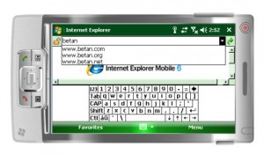

Figure 2 - Windows Mobile‘s on-screen keyboard. [16]

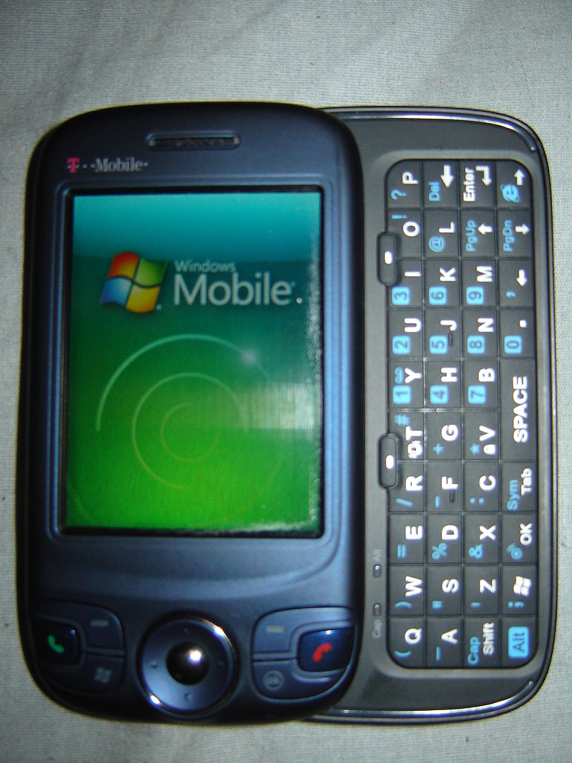

Figure 3 - Keyboard on HTC P4350. [17]

In the laptop world, at the time, another crowd favorite emerged. Having had strong influence on the market during the early days of keyboard development, IBM was back has now done something new.[18] In 1992, they gave us the IBM ThinkPad with its‘ soon-to-beсome legendary keyboard praised for the typing feel and quality. Despite the rather compact size of the device and the limitations of the Scissor-Switch based keyboard, ThinkPads would go on to be unbeaten in the portable world, with the iconic design of the keyboard being largely unchanged throughout the evolution of the device. Even after Lenovo bought IBM’s desktop and laptop computer business in 2005 the keyboards would not see radical change until 2011.

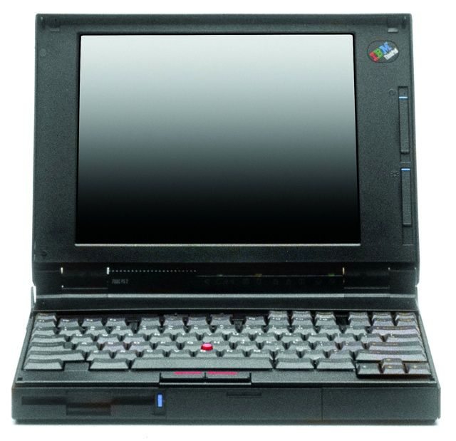

Figure 4 - The iconic 1992 ThinkPad 700. [19]

And so, the keyboard development continued. By the year 2002 the keyboards started getting interesting.

First of all, the idea of making the keyboard illuminated came about. This idea is reflected in a classic 2002 keyboard called *Auravision EluminX*. As early as 2002, this piece had white see-through keycaps and blue LEDs at the base of the board that had, rather badly though, let the key legend be readable in the dark. I personally had a clone of this keyboard and I must say that this idea is dreadful, as transparent keycaps make the black legend unreadable both with and without the backlight.

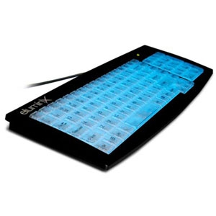

Figure 5 - *Auravision EluminX*. [20]

What came next might come as a surprise, but not later than next year, 2003, the first truly gamer products have arrived. This year saw the release of two products that marked the beginning of what we now know as professional gamer-oriented PC peripherals. These two were: *Ideazon Zboard*, a truly ahead of its‘ time modular Membrane keyboard with different switchable panels for different games, and *Saitek PC Gamers Keyboard*, which had an external keypad for custom keybinds and used the membrane as well.

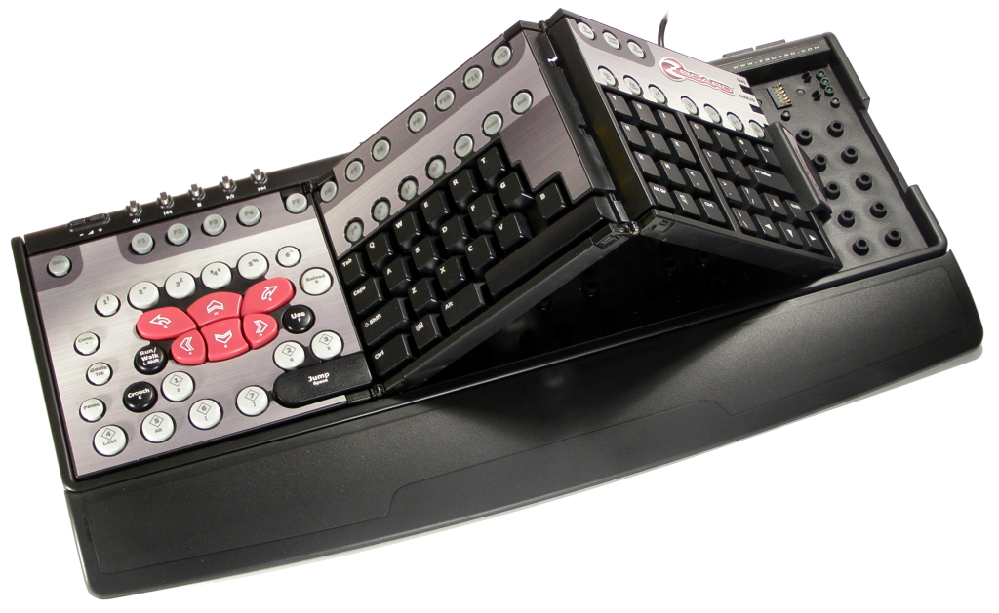

Figure 6 - *Ideazon Zboard* with a FIFA add-on attached. [21]

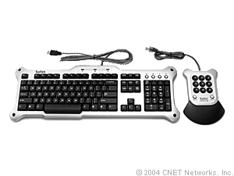

Figure 7 - *Saitek PC Gamers Keyboard* with its extra Keypad. [22]

The next keyboard market revolution has to be credited to Logitech. In 2005, they tried adding something new to a backlit keyboard with a lot of macro keys and what came out was considered an icon at the time: the *Logitech G15*. After this point, backlight became an integral part of a keyboard deemed of the “gaming” title and we still see it today with the latest and greatest keyboards. This keyboard had the luxury of sporting a screen that you could use while gaming which was considered a real novelty piece back then. [23]

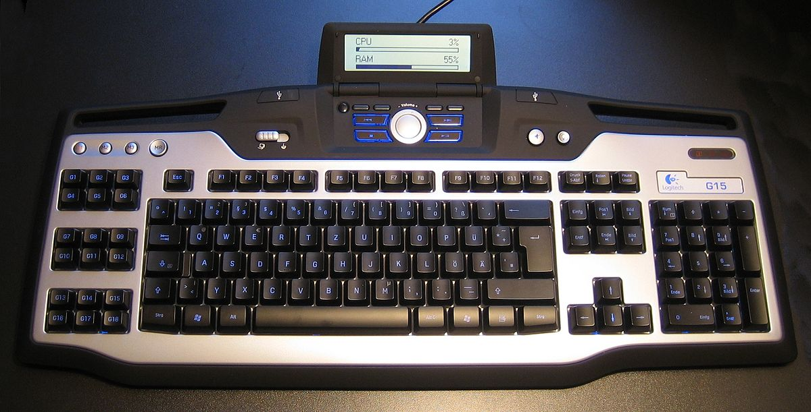

Figure 8 - *Logitech G15* with a Czech layout. [24]

While the desktop keyboards were developing rapidly, mobile typing was rather stagnant during this era. Some developments in bringing a full keyboard were made by BlackBerry, who has put 33 buttons on a phone in as early as 2002 [25], but BlackBerry phones have always been considered a niche product. Of course, mobile typing completely changed in 2007, when the original iPhone has arrived.

The original iPhone has transformed the world in many ways and defining how inputting text is done on touchscreens is just one of them. Touching buttons with your finger was the new norm and styluses were rapidly becoming obsolete. This still was rather clunky due to sheer smallness of the touchscreens of that era, and due to enormous bezels of these screens, however the iPhone has started advances towards eliminating that as well.

2007 was also an important year for ergonomic keyboards. Of course, the idea of an ergonomic keyboard wasn’t new at this point, with interesting ideas being put into products as early as 1977 with *Maltron*[26] and later, *Kinesis* keyboards[27] as well as persistent efforts from Microsoft, earliest being *Microsoft Natural Keyboard* in 1994, but all these products had one fatal flaw: they were very expensive. When *Logitech Wave* came out in 2007, this all changed. Ergonomic was now just $100 away.

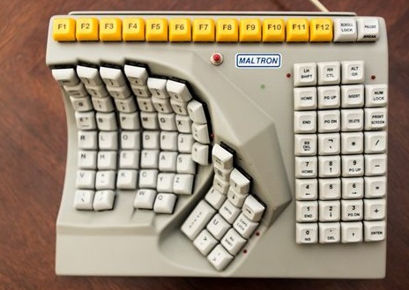

Figure 9 - *Maltron* keyboard. (1977) [26]

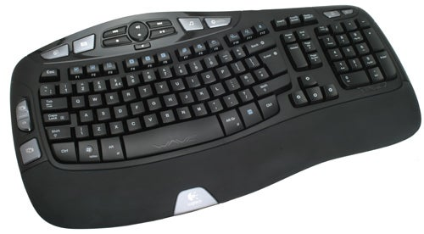

Figure 10 - *Logitech Wave*. [28]

However, the keyboard market was far from being fulfilled. Throughout late 1990s and early 2000s the Mechanical keyboard market was noticeably thin because most brands have chosen to invest in different, cheaper keyboard innovations, as shown before. But this could not last forever and by 2008 the Mechanical switch was slowly but steadily making a comeback.

The first important milestone was reached when in 2008, SteelSeries, a Denmark-based gaming peripherals company has released a spiritual successor to their *6Gv2* keyboard: the *SteelSeries 7G.* To us it is interesting because, unlike the *Zboard* or the *G15* this keyboard took a different approach to “gaming” gear. Instead of adding new features, this keyboard aimed to improve the core performance of the keyboard: minimizing input response delay, maximizing the number of simultaneous keypresses and of course, most importantly, incorporating Cherry MX mechanical switches. [29] This marks an important moment in keyboard development. Suddenly, every key market player started to realize that gamers cared more about how the keyboard “felt” more than the macro keys and LCD screens.

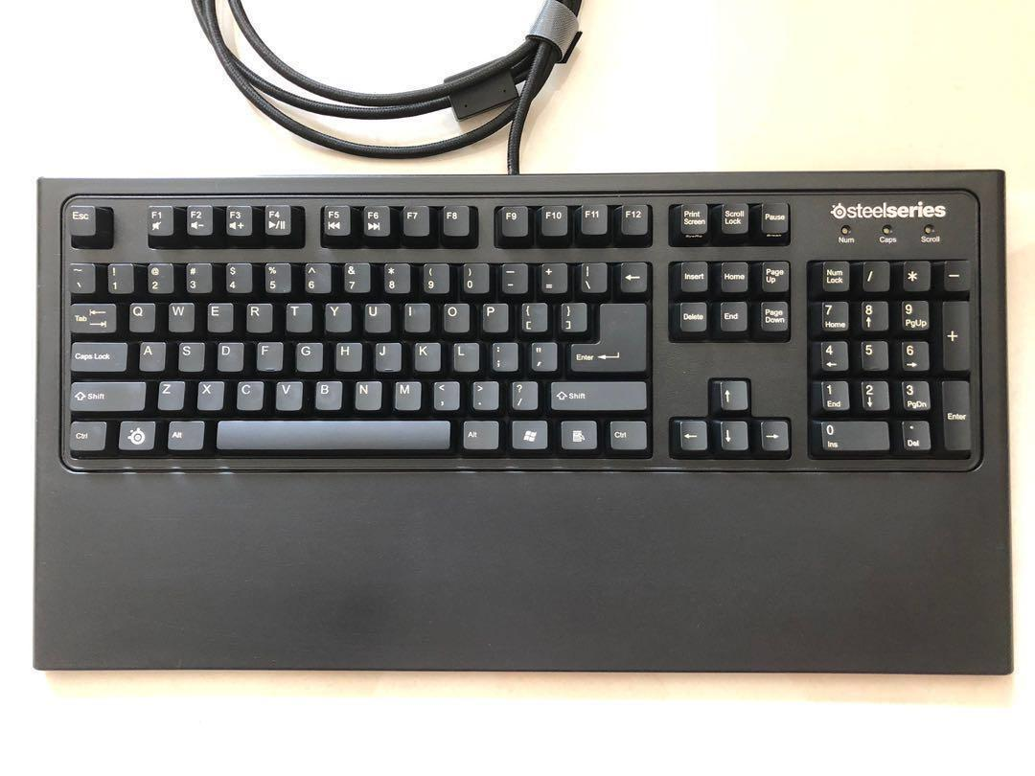

Figure 11 - *SteelSeries 7G* with a handrest attached. [30]

In the same year, the first Android smartphone was just preparing for launch. We know Android today as one of the main competitors of Apple’s iOS, but back then it was just one of the systems that were preparing to launch to rival the original iPhone. Throughout its development, the team behind the Android project was imagining something that did not look at all like the contemporary Android-based mobile phones we have now. The team was imagining a horizontal screen with rows of physical buttons. [31]

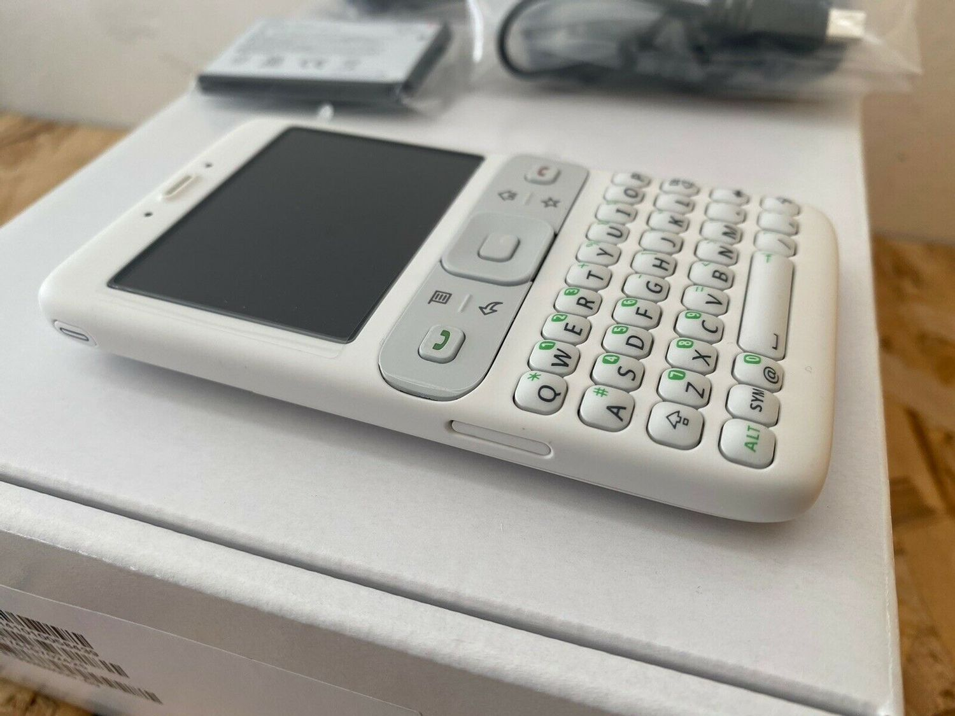

Figure 12 - Early Android phone prototype. [32]

The release of the iPhone in 2007 made the team rethink the concept and, following the announcement of touchscreen phones from rival market players, the team switched focus to touchscreens as well. What eventually came out in September 2008 was a phone that, while including a slider-type hidden hardware keyboard, was obviously aimed towards touchscreen use with the inclusion of on-screen virtual keyboard, just as the iPhone had. Models that followed would mostly opt-out of inclusion of physical keyboard and be purely touchscreen focused.

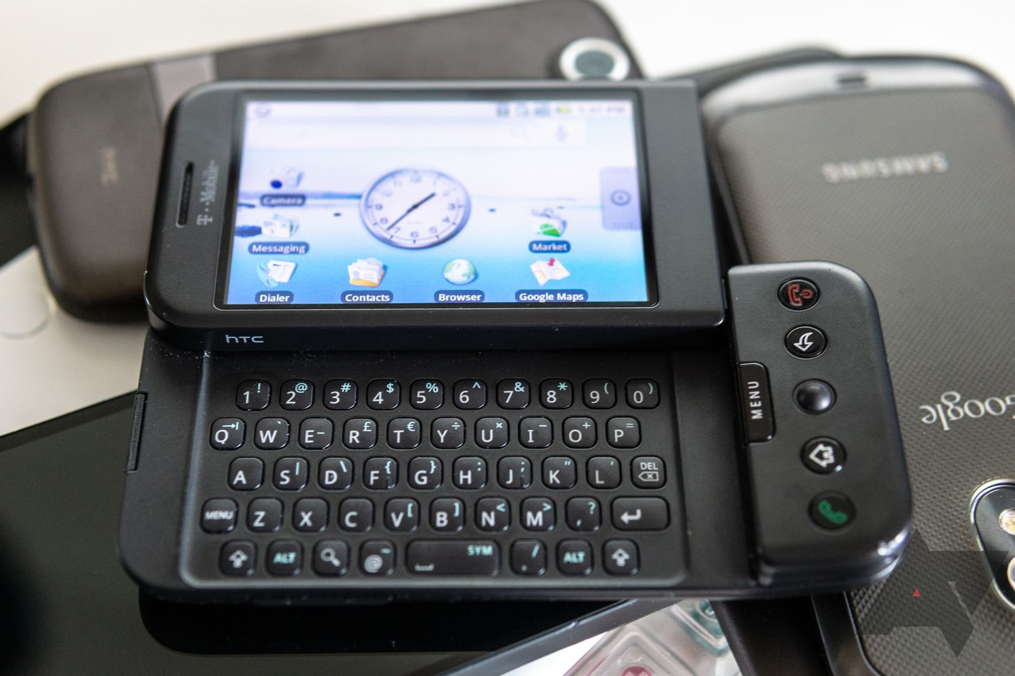

Figure 13 - HTC Dream with the keyboard exposed. [33]

In 2009 Logitech has updated the *G15* to feature two powered USB 2.0 ports, improved RGB backlight and a full color LCD screen with additional functionality. The model was called *G19*. This was the pinnacle of the Membrane switch-era Logitech, as all the following flagship models following the “facelift” of the *G19*, the *G19s*, used Mechanical switches. Later that year, a new, revolutionary way of mobile typing was just being launched. Being in development from 2003 [34] and first coming pre-installed with selected Windows Mobile phones, with Android version entering development in 2010, Swype was rapidly becoming a new thing.

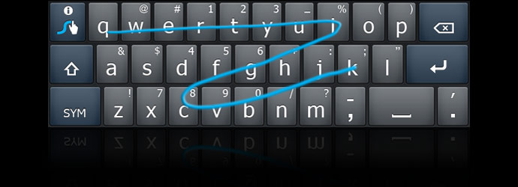

Figure 14 - Swype keyboard in action. [35]

What made Swype so great was the sheer speed of typing you could achieve by “swyping” your finger around the on-screen buttons, as opposed to typing them one-by-one. Swype used prediction algorithms to recognize the words typed by the user, which meant that the competitors had a long way to go before catching up to the speed and accuracy of Swype’s algorithm. [35] What definitely slowed down the spread of Swype, though, was their strange decision to not distribute the app for Android through the Google Play Market, instead opting for a purchase through their own site. That meant that by the time Swype came to the Play Market in 2013, they have already been beat to the punch with keyboard apps that offered the same functionality: SlideIt and SwiftKey. [36]

What happened next, in 2010, needs to be regarded as one of the key reasons why the Mechanical Switch is as popular as it is today. Razer, a gamer peripherals maker, has realized that all, that mechanical keyboards lacked at the time, was style. [37]  And they delivered with the iconic *Razer BlackWidow* and its’ big brother *BlackWidow Ultimate* which offered backlight on top of the already wonderful to touch Cherry MX Blue switches and 5 fully customizable macros keys present in the cheaper model. The aggressive design and instantly recognizable clicking of the switches that were more oriented towards typing than gaming [38] drew everyone’s attention to the model and the Mechanical Switch keyboards as a whole. I personally have been saving for over a year for this keyboard in my teen years, and when I got the *Ultimate 2013* model the user experience was even better than described.

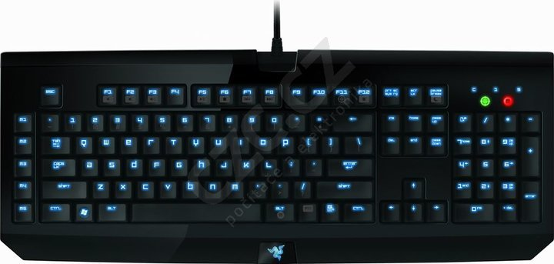

Figure 15 - *Razer BlackWidow Ultimate*. [39]

### The keyboard renaissance

The release of this keyboard and subsequent heavy marketing by Razer was the very moment having a Mechanical keyboard became cool again. But Razer hasn’t stopped there, and at the same year they would go on to launch a product that jumpstarted another fad that is as popular as ever today. The product in question was the Razer Nostromo, a fully customizable and reprogrammable keypad with (at the time) Membrane switches and a wristrest. Suddenly, everyone realized that you did not have to have a full-size keyboard to get the keyboard experience. [40]

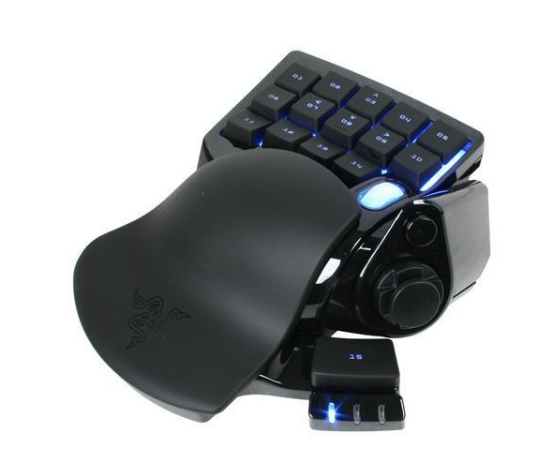

Figure 16 - Razer Nostromo. [41]

And, while the development of smaller keyboards is and old story, with earlier products being the *IBM Space Saving Keyboard* [42] and *Happy Hacking* keyboard in 1995 [43] the real “boom” of “ten-keyless” (as they soon became called) keyboards has happened in 2011-2012 with SteelSeries, Logitech, Razer and many more companies producing smaller versions of their most popular keyboards.

Years 2011 and 2012 also saw releases of some models from newcomers in the PC keyboard market that would soon earn them the reputation of a trusted brand. First of these models was the *Das Keyboard Model S Ultimate*, released in 2011, which Das themselves saw as a successor to the iconic *IBM Model M*. It was aimed at a high-end consumer market, had Mechanical switches and, somewhat questionably, had removed all legend from keycaps. [44]  A computer part supplier Cooler Master that previously has entered the PC peripherals market had released the *Quick Fire Rapid* model in 2012, which was mechanical, didn’t include the numpad and most importantly, was cheap: compared to the “luxurious” *Model S Ultimate*’s $159 price tag the *Quick Fire Rapid* was modestly priced at $79.99. [45] This brought a lot of attention to the ten-keyless keyboard market with many competitors starting work on their versions of the successful Cooler Master product. Another newcomer to the PC peripherals market was Corsair with their *Vengeance K90,* which used Cherry MX switches and was aimed towards MMO players with its whopping 18 macro keys.

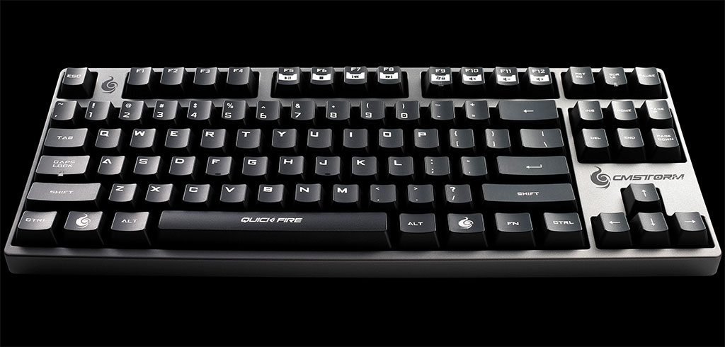

Figure 17 - *Cooler Master Quick Fire Rapid*. [45]

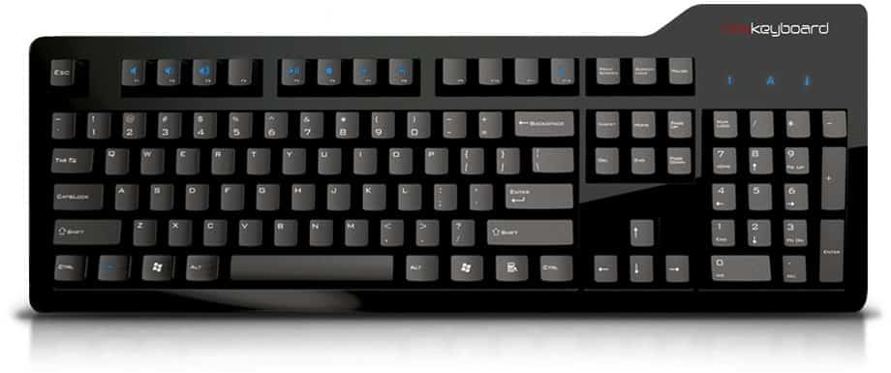

Figure 18 - *Das Keyboard Model S Professional*, which had the legend on it. [46]

The same year, we got more proof that the Membrane switch was giving way to the Mechanical one. Mad Catz tried to revive the LCD screen fad that the Logitech started, but what came out instead was a somewhat controversial product. The keyboard was named *S.T.R.I.K.E. 7* to be in line with the earlier R.A.T. computer mice that Mad Catz had been producing prior. It had every feature imaginable: a full LCD screen with tons of functions, the modular design with the ability to detach part of the keyboard and use it separately and two handrests that could be attached in two separate ways. The only thing that the keyboard lacked was the feel: despite all the features, Mad Catz skipped out on Mechanical switches, claiming instead that they have achieved the “feel” of the mechanical keyboard, which was not true. [47]

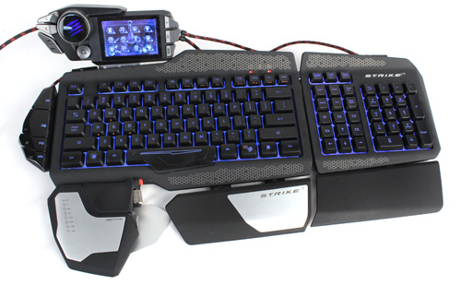

Figure 19 - *Mad Catz S.T.R.I.K.E. 7* in its regular form. [47]

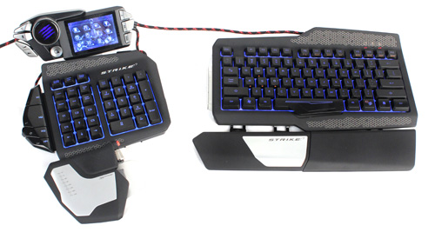

Figure 20 - *Mad Catz S.T.R.I.K.E. 7* with separated modules. [47]

The keyboard, however, turned out to be a flop as owners criticized the mushy feeling keys and lack of support for the LCD screen. Lack of support from external developers was obvious, as no one wanted to spend time developing for an incredibly niche keyboard that sold very poorly, and certainly no one wanted to do it for free. Nobody has tried to put a giant screen on a keyboard ever since.

Next year, in 2013, Logitech has returned with another flagship keyboard, but this time they were offering something that they have never done before. The new *G710+* used Cherry MX Brown switches and was an overall improvement to Logitech’s design.

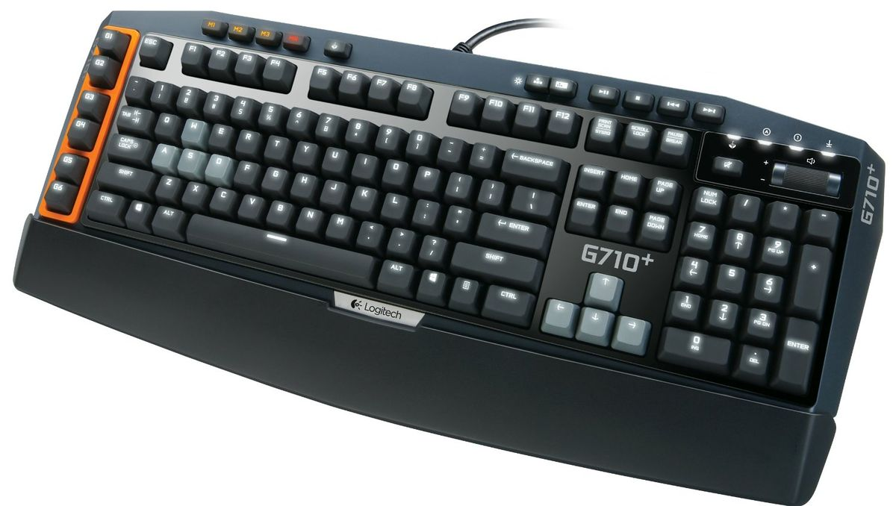

Figure 21 - *Logitech G710+.* [48]

This meant that now almost every professional-grade keyboard maker had a Mechanical model in their lineup. And, with new companies joining the Mechanical keyboard market every year it was getting more competitive than ever. In 2014, Cherry’s patent for their MX switch expired and the market became filled with keyboards using cheap clones of the original design.

After Mechanical switch keyboards became widespread and inexpensive, as always, it was time for something new. Most companies who made professional-grade keyboards have either invested into developing Mechanical switches or funded other developments to use later in their products and by year 2016 the market was completely transformed.

In 2016, A4Tech and Adomax, companies with reputation in the computer world, have developed Optical Mechanical switches: the Light Strike and Flaretech, respectively. This type of switch was unique at the time of invention. It did not have electronics in the switch modules, instead having components on the circuit board perform the sensing. [49] This invention led to a joint development of a Type B Adomax Flaretech switch between Adomax themselves and Wooting, a small company funded by Kickstarter backers. And surprisingly, this time a crowdfunded project actually came together and *Wooting One* was released. It was the first Analog keyboard in the world, in this context meaning that the keyboard could sense how hard the user was pressing each key. It could switch between Digital and Analog modes, tweaking the activation points, adjust the Analog curve, and much more. Despite the lack of support for the analog key sensing from major game and software developers, the technology behind the product was truly remarkable. The keyboard was successful and eventually saw a successor.

In 2019, however, the list of available analog keyboards has expanded to include the *Cooler Master MK850* with two precision wheels, Cherry MX switches and Analog input on a 8 key cluster from Q to F, which was priced at whopping $200. [50] Later that year SteelSeries, who has commissioned Gateron, a well trusted mechanical switch maker, to make them a new switch has released the *SteelSeries Apex Pro*. The new OmniPoint switch improved the old Hall Effect technology to add Analog input support, and SteelSeries claims that the response time of the keys is up to 8 times faster then other Mechanical switches. [51] In the beginning of the next year, Wooting has collaborated again, this time with Gateron, to make a linear Hall Effect switch that would make more sense with Wooting’s Analog ideology on the *Wooting Two*. The Lekker switch, as it was called, would provide Analog sensing over the full key travel range. [52] And no later than 2021, Razer has joined the competition with a different approach. They have worked on the third generation of A4Tech’s switch to add Analog sensing to their keyboards and in 2021 have released the *Razer Huntsman V2 Analog*, priced at $250. [53]

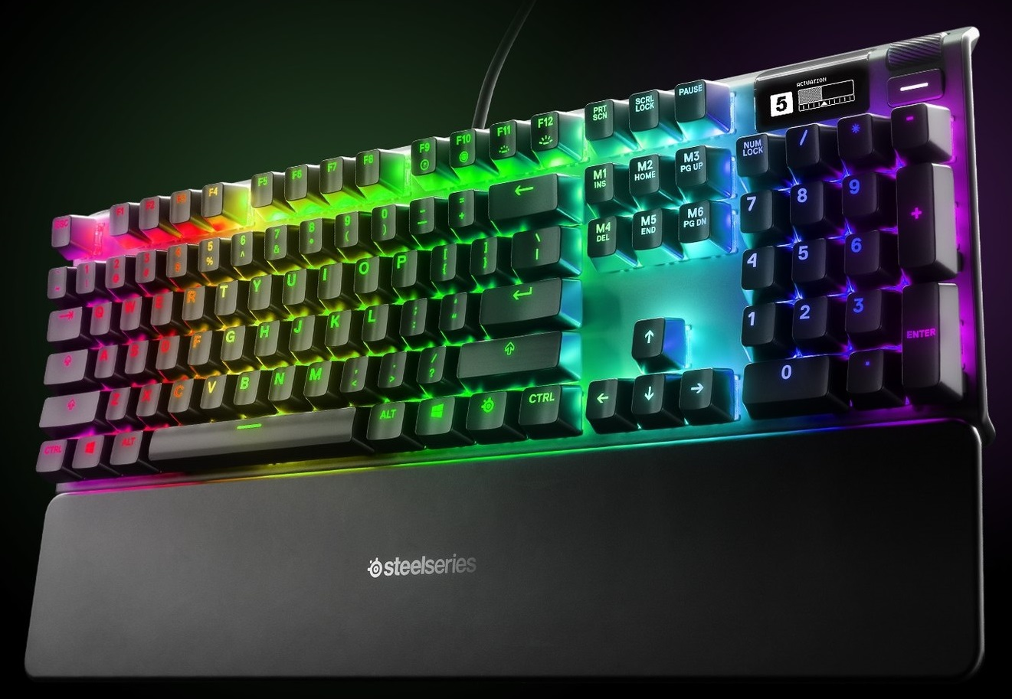

Figure 22 - *SteelSeries Apex Pro*. [54]

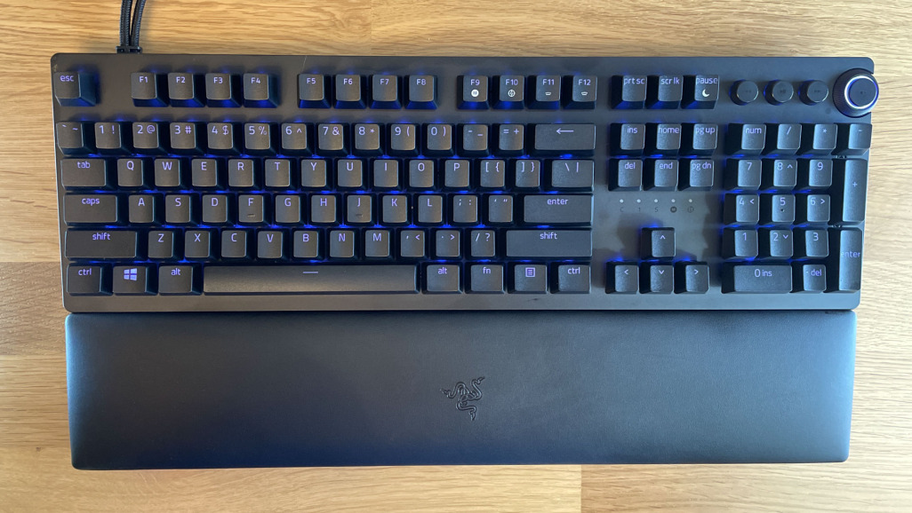

Figure 23 - *Razer Huntsman V2 Analog*. [53]

The market for optical keyboards, however, was only increasing, and even by 2021, the *Huntsman* was already only one of the choices, and not always the best one. [55] Moreover, by 2021 it was clear that almost every manufacturer tried to cash-in on the Mechanical craze after Cherry lost its patent. Razer had the Green/Yellow/Orange switches mimicking the original Blue/Red/Brown lineup, SteelSeries had QX2 Blue/Brown/Red switches and Logitech even managed to go through two generations of switches: first, the Romer-G lineup and then the Logitech GX Blue. What united all these efforts, though, is that they haven’t managed to surpass the original German Cherry quality control or typing feel and would go on to stay in history as mere clones of the original design, just like the other copies in production from 2014.

What also needs to be noted is the trend in recent years to add more ways of interacting with the computer on the keyboard itself. Many companies are doing it. Its presence can be noted on the latest models discussed in this work. Razer includes an Analog turning wheel that can be set to perform various functions in the software (Figure 23), SteelSeries has a customizable roller (Figure 22), the *Cooler Master MK850,* aspreviously discussed, had **two** of these rollers. Recently, Apple has added a touchpad to where the F keys row used to be on their premium laptops, and while I think that giving the user additional means of control is useful and interesting, robbing us of something to give us these controls isn’t optimal.

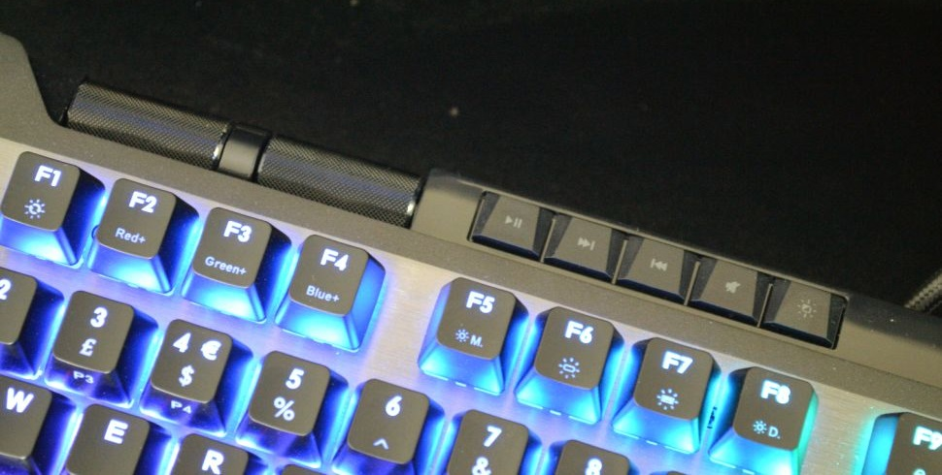

Figure 24 - Two adjustable rollers on the *Cooler Master MK850*. [50]

# List of figures

Figure 1 - *IBM Model M*. [6] 2

Figure 2 - Windows Mobile‘s on-screen keyboard. [16] 4

Figure 3 - Keyboard on HTC P4350. [17] 4

Figure 4 - The iconic 1992 ThinkPad 700. [19] 5

Figure 5 - *Auravision EluminX*. [20] 5

Figure 6 - *Ideazon Zboard* with a FIFA add-on attached. [21] 6

Figure 7 - *Saitek PC Gamers Keyboard* with its extra Keypad. [22] 6

Figure 8 - *Logitech G15* with a Czech layout. [24] 6

Figure 9 - *Maltron* keyboard. (1977) [26] 7

Figure 10 - *Logitech Wave*. [28] 7

Figure 11 - *SteelSeries 7G* with a handrest attached. [30] 8

Figure 12 - Early Android phone prototype. [32] 8

Figure 13 - HTC Dream with the keyboard exposed. [33] 8

Figure 14 - Swype keyboard in action. [35] 9

Figure 15 - *Razer BlackWidow Ultimate*. [39] 9

Figure 16 - Razer Nostromo. [41] 10

Figure 17 - *Cooler Master Quick Fire Rapid*. [45] 10

Figure 18 - *Das Keyboard Model S Professional*, which had the legend on it. [46] 11

Figure 19 - *Mad Catz S.T.R.I.K.E. 7* in its regular form. [47] 11

Figure 20 - *Mad Catz S.T.R.I.K.E. 7* with separated modules. [47] 11

Figure 21 - *Logitech G710+.* [48] 12

Figure 22 - *SteelSeries Apex Pro*. [54] 13

Figure 23 - *Razer Huntsman V2 Analog*. [53] 13

Figure 24 - Two adjustable rollers on the *Cooler Master MK850*. [50] 13

# Bibliography

1. CASSINGHAM, R. C., *The Dvorak Keyboard*. Arcata, California: Freelance Communications, 1986. 94s. ISBN: 0-935309-10-1, pp. 21-24, 27.
2. EDWARDS, B. *The 10 Worst PC Keyboards of All Time*. [online]. [cit. 2022-03-08]. <<https://www.pcworld.idg.com.au/slideshow/214894/10-worst-pc-keyboards-all-time/>>
3. REED, M. *Model I Keybounce.* [online]. [cit. 2022-03-08]. <<http://www.trs-80.org/model-1-keybounce/>>
4. GOOGLE PATENTS. *Buckling spring torsional snap actuator*. [online]. [cit. 2022-03-08]. <<https://patents.google.com/patent/US4118611>>
5. BEIJNUM, I.V. *Why I use a 20-year-old IBM Model M keyboard.* [online]. [cit. 2022-03-08]. <https://arstechnica.com/gadgets/2018/11/why-i-use-a-20-year-old-ibm-model-m-keyboard/>
6. RTINGS. *IBM Model M Keyboard Review.* [online]. [cit. 2022-03-08]. <<https://i.rtings.com/assets/products/ZDmfP7qT/ibm-model-m/design-medium.jpg>>
7. LEKASHMAN, A. *History Of Mechanical Keyboards.* [online]. [cit. 2022-03-08]. <<https://www.tomshardware.com/picturestory/736-history-of-mechanical-keyboards.html/>>
8. BEARDSMORE, D. *Hall effect*. [online]. [cit. 2022-03-08]. <<https://telcontar.net/KBK/tech/Hall_effect>>
9. DESKTHORITY. *Space-cadet keyboard*. [online]. [cit. 2022-03-08]. <https://deskthority.net/wiki/Space-cadet_keyboard>
10. KEYBOARDEXPERT. *Capacitive Keyboards – What Are They How & Do They Work?* [online]. [cit. 2022-03-08]. < https://keyboardsexpert.com/capacitive-keyboards/#Brief_History_of_Capacitive_Keyboards>
11. KEYBOARDEXPERT. *Optical vs. Mechanical Keyboard – What are the Differences?* [online]. [cit. 2022-03-08]. < https://keyboardsexpert.com/optical-vs-mechanical-keyboard/>
12. WIKIPEDIA. *Optical keyboard technology*. [online]. [cit. 2022-03-08]. <https://en.wikipedia.org/wiki/Keyboard_technology#Optical_keyboard_technology>
13. DESKTHORITY. *Burroughs Opto-Electric*. [online]. [cit. 2022-03-08]. <https://deskthority.net/wiki/Burroughs_Opto-Electric>
14. MEMTRONIK INC. *The evolution of the membrane switch – or, a brief history of a revolutionary technology!* [online]. [cit. 2022-03-08]. <https://www.memtronik.com/the-evolution-of-the-membrane-switch-or-a-brief-history-of-a-revolutionary-technology>
15. TILLEY, C. *The History of Microsoft Windows CE - Windows CE 1.0x*. [online]. [cit. 2022-03-08]. <https://www.hpcfactor.com/support/windowsce/history/ce1/>
16. FULTON, S. M. III. *The on-screen keyboard in IE Mobile 6 for Windows Mobile 6.1.4.* [online]. [cit. 2022-03-08]. <<https://betanews.com/the-on-screen-keyboard-in-ie-mobile-6-for-windows-mobile-6-1-4/>>
17. WIKIPEDIA. *HTC P4350.* [online]. [cit. 2022-03-08]. <<https://en.wikipedia.org/wiki/HTC_P4350>>
18. DESKTHORITY. *ThinkPad keyboard*. [online]. [cit. 2022-03-08]. <https://deskthority.net/wiki/ThinkPad_keyboard>
19. RUGGEDPORTABBLE. *1992: The IBM Thinkpad 700.* [online]. [cit. 2022-03-08].  *<*<https://www.rugged-portable.com/history-portable-computers-rugged-bias/ibm-thinkpad-700/>>
20. TIGERDIRECT. *Auravision EluminX Black with Blue / Sapphire Illuminated Keyboard.* [online]. [cit. 2022-03-08]. <https://www.tigerdirect.com/applications/SearchTools/item-details.asp?EdpNo=518917>
21. ECKSTEIN, F. *Ideazon Zboard ZBD101 | Kapitola 4.* [online]. [cit. 2022-03-08]. <<https://pctuning.cz/article/ideazon-zboard-zbd101?chapter=4>>
22. ALATEST. *Saitek PC Gamers Keyboard.* [online]. [cit. 2022-03-08]. <<https://alatest.com/reviews/keyboard-reviews/saitek-pc-gamers-keyboard/po3-20964,90/>>
23. BROWN, R. *Logitech G15 Gaming Keyboard review:* [online]. [cit. 2022-03-08].  *<*<https://www.cnet.com/reviews/logitech-g15-gaming-keyboard-review/>>
24. WIKIPEDIA. *Logitech Gaming Keyboard G15*. [online]. [cit. 2022-03-08].  *<*<https://en.wikipedia.org/wiki/File:Logitech_Gaming-Keyboard_G15.jpg>>
25. LEUNG, I. *BlackBerry Limited.* [online]. [cit. 2022-03-08]. <https://www.thecanadianencyclopedia.ca/en/article/blackberry-limited#:~:text=Founded%20in%201984%20by%20Mike,and%20later%20the%20general%20public.>
26. MALTRON. *Maltron History.* [online]. [cit. 2022-03-08].  *<*<https://www.maltron.com/maltron-history.html>>
27. WikiWikiWeb. *Kinesis Keyboard,* [online]. [cit. 2022-03-08]. <<https://wiki.c2.com/?KinesisKeyboard>>
28. VANDERVELL, A. *Logitech Wave Keyboard Review.* [online]. [cit. 2022-03-08].  <<https://www.trustedreviews.com/reviews/logitech-wave-keyboard\>>
29. CROSS, J. *SteelSeries 7G Keyboard Review.* [online]. [cit. 2022-03-09].  <<https://www.extremetech.com/computing/79544-steelseries-7g-keyboard-review>>
30. CAROUSELL. *SteelSeries 7G Mechanical Keyboard.* [online]. [cit. 2022-03-09].  <https://www.carousell.sg/p/steelseries-7g-mechanical-keyboard-210731979/>
31. IONESCU, D. *Original Android Prototype Revealed During Google, Oracle Trial.* [online]. [cit. 2022-03-10]. <https://www.pcworld.com/article/464050/original_android_prototype_revealed_during_google_oracle_trial.html>
32. HAGER, R. *Unreleased prototypes of the first Android phone appear on eBay.* [online]. [cit. 2022-03-10]. <https://www.androidpolice.com/2020/03/19/unreleased-prototypes-of-the-first-android-phone-appear-on-ebay/>
33. HAGER, R. *Using the HTC G1, 10 years later: 2008's smartphone is effectively a dumbphone in 2018.* [online]. [cit. 2022-03-10]. <https://www.androidpolice.com/2018/12/24/using-htc-g1-10-years-later-2008s-smartphone-effectively-dumbphone-2018/>
34. UNITED STATES PATENT. *System and method for continuous stroke word-based text input.* [online]. [cit. 2022-03-12]. *<https://patft.uspto.gov/netacgi/nph-Parser?Sect1=PTO1&Sect2=HITOFF&d=PALL&p=1&u=%2Fnetahtml%2FPTO%2Fsrchnum.htm&r=1&f=G&l=50&s1=7,098,896.PN.&OS=PN/7,098,896&RS=PN/7,098,896>*
35. SWYPE. *What is Swype?* [online]. [cit. 2022-03-12]. <http://webarchive.loc.gov/all/20101004212941/http://swypeinc.com/product.html>
36. RICE, J. *Swype Finally Arrives In The Google Play Store For $0.99, Playing Catch-Up In A Race It Invented [Update: Trial Version]* [online]. [cit. 2022-03-12]. <https://www.androidpolice.com/2013/04/23/swype-finally-arrives-on-the-google-play-store-for-0-99-playing-catch-up-in-a-race-it-invented/>
37. KEYBOARDEXPERT. *History of Gaming Keyboards – A Look Back In Time.* [online]. [cit. 2022-03-12]. <https://keyboardsexpert.com/history-of-gaming-keyboards/#Razer_BlackWidow_2010>
38. MECHANICALKEYBOARDS. *Cherry MX Blue.* [online]. [cit. 2022-03-12]. <https://mechanicalkeyboards.com/switches/index.php?switch=Cherry-MX-Blue>
39. CZC.CZ. *Razer BlackWidow Ultimate, US.* [online]. [cit. 2022-03-12]. <https://www.czc.cz/razer-blackwidow-ultimate-us/90209/produkt>
40. PCMAG. *Razer Nostromo.* [online]. [cit. 2022-03-12].<https://uk.pcmag.com/keyboards/22731/razer-nostromo>
41. NEWEGG. *Razer Nostromo PC Gaming Keypad.* [online]. [cit. 2022-03-12].<https://www.newegg.com/p/N82E16823114015>
42. DESKTHORITY. *IBM Space Saving Keyboard.* [online]. [cit. 2022-03-12].<https://deskthority.net/wiki/IBM_Space_Saving_Keyboard>
43. HHKEYBOARD. *HHKB history.* [online]. [cit. 2022-03-12].<https://www.hhkeyboard.com/uk/history>
44. CNET. *Das Keyboard review.* [online]. [cit. 2022-03-12].<https://www.cnet.com/reviews/das-keyboard-review/>
45. TECHPOWERUP. *Cooler Master Announces CM Storm Quick Fire Rapid Mechanical Gaming Keyboard.* [online]. [cit. 2022-03-12].<https://www.techpowerup.com/153812/cooler-master-announces-cm-storm-quickfire-rapid-mechanical-gaming-keyboard>
46. DAS KEYBOARD. *Model S Professional.* [online]. [cit. 2022-03-12].<https://www.daskeyboard.com/model-s-professional/>
47. LU, J. *Mad Catz S.T.R.I.K.E. 7 Keyboard - A Modular Approach To Gaming Keyboards.* [online]. [cit. 2022-03-12]. *<https://www.hardwarezone.com.sg/review-mad-catz-strike-7-keyboard-modular-approach-gaming-keyboards>*
48. DESKTHORITY. *G710+.* [online]. [cit. 2022-03-13]. <https://deskthority.net/wiki/File:G710%2B.jpg>
49. DESKTHORITY. *Adomax Flaretech.* [online]. [cit. 2022-03-14]. <https://deskthority.net/wiki/Adomax_Flaretech>
50. COX, A. *Cooler Master Master Keys MK850 Gaming Keyboard Review: Analog Excellence.* [online]. [cit. 2022-03-14].<https://www.tomshardware.com/reviews/cooler_master-masterkeys_mk850-gaming-keyboard,6101.html>
51. THALER, M. *The World’s Fastest Mechanical Switch.* [online]. [cit. 2022-03-14]. <https://steelseries.com/blog/worlds-fastest-mechanical-switch-105>
52. WOOTING. *Wooting Two Lekker edition.* [online]. [cit. 2022-03-14]. <https://wooting.io/wooting_two_lekker>
53. EPSTEIN, M. *Razer Huntsman V2 Analog Optical Gaming Keyboard Review.* [online]. [cit. 2022-03-14]. <https://www.pcmag.com/reviews/razer-huntsman-v2-analog-optical-gaming-keyboard>
54. STEELSERIES. *SteelSeries Apex Pro.* [online]. [cit. 2022-03-14]. <https://steelseries.com/gaming-keyboards/apex-pro>
55. JUE, R. *The Best Optical Keyboards [2021].* [online]. [cit. 2022-03-14]. <https://switchandclick.com/the-best-optical-keyboards/>